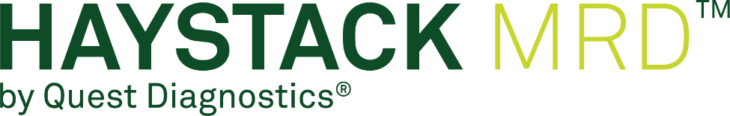

Early Experience Program digital promo kit

Haystack MRD™ by Quest Diagnostics® product description
Haystack MRD™ is a tumor-informed minimal residual disease (MRD) test that detects ultralow levels of ctDNA with unparalleled sensitivity to uncover residual disease in patients with cancer. Haystack’s technology is the result of 20 years of research by pioneers in cancer genomics. Its purpose-built, high-precision science delivers novel insights that can shape optimal treatment decisions personalized for each patient. Haystack MRD is part of Quest Diagnostics®, making the transition between MRD testing and other oncology portfolio offerings seamless for easier, more streamlined patient care.

Social media
Haystack MRD handles
- LinkedIn: @HaystackOncology
- X (formerly Twitter): @HaystackMRD

LinkedIn | Thrilled to announce my participation in the Haystack MRD Early Experience Program by Quest Diagnostics. This program grants me early access to their next-gen ctDNA detection test, helping to provide critical insights into cancer status so I can make more-informed decisions for my patients. Ready to revolutionize cancer care!
LinkedIn | I take great pride in being on the forefront of cancer research and technology. I’m therefore honored to be part of Quest Diagnostics Haystack MRD Early Experience Program. This initiative grants early access to Haystack MRD, a next-gen ctDNA detection test that helps to provide a deeper understanding of cancer status so I can make more-informed treatment decisions for my patients. Looking forward to elevating cancer care!
LinkedIn | I’m delighted to announce my involvement in the Haystack MRD Early Experience Program by Quest Diagnostics. This program grants early access to their Haystack MRD ctDNA detection test, a remarkable technology developed over 2 decades. By using this highly sensitive test, I can gain invaluable insights into cancer status, helping me to make more informed decisions about my patient’s treatment. Sensitive ctDNA detection has the potential to revolutionize cancer care, and I’m excited to be a part of this journey.
X | Thrilled to join the @HaystackMRD Early Experience Program by @QuestDX! Haystack MRD detects ultralow ctDNA levels, providing vital insights into cancer status in patients. It's a huge advancement in cancer care, and I'm looking forward to seeing how this tech transforms the field.
X | Excited to be a part of the @HaystackMRD Early Experience Program by @QuestDX! We can now detect ultralow levels of ctDNA, providing crucial info on cancer status in patients. This knowledge will help enhance treatment decisions. Together, let's revolutionize cancer care!
X | Joining forces with @HaystackMRD in the Early Experience Program by @QuestDX—unlocking the potential of next-generation MRD detection and gaining unique insights. Ready to make more-informed treatment decisions for our cancer patients.
X | I'm thrilled to announce that I’m part of the @HaystackMRD Early Experience Program by @QuestDX, which grants early access to their innovative ctDNA detection test. This is a major milestone that can help with cancer care, and I can't wait to witness how it revolutionizes the field.

